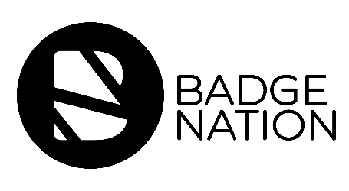

Who: Badge Earner
When: 3 days after Email 1 (badge issuing)
How: Send by Learning Provider
Why: To educate about what they can do with their badge

Subject line: Get the most out of your digital badge
From: Learning Provider email

We recently got in touch to let you know you were issued with the [insert badge name here] digital badge. We hope you are happy with your badge and have accepted the invitation to claim it, but what now?

Here are some things you can do with your badge:

- Share your badge on Facebook, Twitter, Instagram or LinkedIn. A recent study has found that digital credentials increase profile views by 600%! Check out this video to quickly add your new badge to your LinkedIn profile.

- Add your badge to your CV to stand out from the crowd when making job applications. Employers are interested in your skills and what you do in your time out of work and education - badges help you to demonstrate this. You can find out how to embed your badge on a CV in this blog post.

- Go to Navigatr for your next move! Find activities to earn more badges and embark on new learning journeys with pathways.

If you have not yet accepted your badge but would like to, you can do this by finding your notification email from Credly.

Email notifications can sometimes end up in your junk folder, so be sure to check there if your notification from Credly hasn’t arrived in your inbox.

