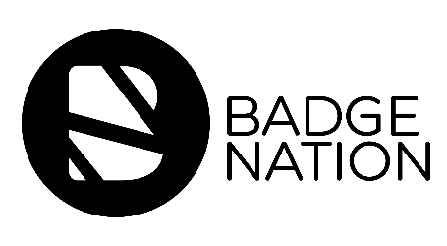

Who: Badge Earner
When: At the same time that the badge is issued
How: Email from Learning Provider
Why: To show them how they can claim their badge

Subject line: Your New Digital Badge!
From: Learning Provider email

Congratulations - you have been issued with the [insert badge name here], which recognises the skills that you have learned during [insert learning activity here]!

Digital badges are the future of recognising skills and can help you to explain your strengths, share your achievements and stand out from the crowd.

You will have received an email from Credly, the global badge hosting platform which we used to issue your badge. This email contains a link and some simple instructions to claim your badge. Sometimes this email can end up in your junk folder, so be sure to check there if it hasn’t landed in your inbox.

If you haven’t done so already, you will be instructed to set up an account on the platform. This video will take you step-by-step through the process of setting up your account and claiming your badge. It’s under three minutes long so please do check it out if you are confused or need any help!

Your badge is part of Badge Nation - a community of organisations committed to recognising what people achieve and accomplish outside of formal qualifications, motivating learning and ambition through digital badges.

